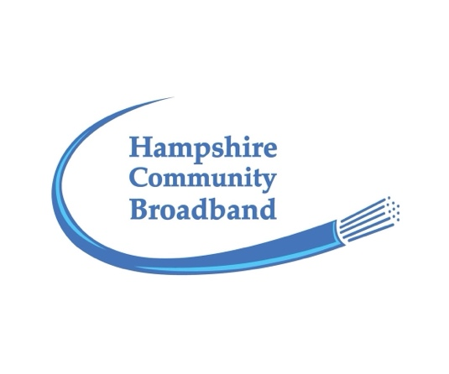
Email: support@hampshirebroadband.co.uk
Telephone Number:01635 800 360
Web: www.hampshirebroadband.co.uk

SUMMARY OF HAMPSHIRE BROADBAND LTD TERMS & CONDITIONS.
full details of which are also on the website.
Previous version May 2024
Updated current version October 2025

Hampshire Broadband Ltd trading as Hampshire Community Broadband (herein referred to as HCB, the Company or we/us) is a community led company based in North Hampshire with local shareholders and local directors. We have a simple aim; to provide you with world class broadband to meet your household’s expanding needs, today and in the future.

Our full Terms & Conditions can be found on our website (they can only be varied with one month’s notice to customers in writing). Whilst we recommend you read the full terms prior to signing-up, here is a quick summary of the key issues addressed (in any case of contradiction, the full Terms and Conditions will prevail).

Cooling off period - Residential customers have the right to cancel their service at no charge within 14-days of accepting the start of their service (i.e. connection).

Contract Term - Initial fixed term of 12-months, followed by a rolling contract subject to 6-months’ notice to terminate. In other words, your initial HBL subscription term is 18-months. You can serve 6-months’ notice any time after the anniversary of the initial fixed term start date. Or should you wish to leave the network earlier via the Gov.’s ‘One Touch Switching’, you may do so following the stated procedures including settling subscriptions to the end of the Contract Term.

You can transfer your subscription should you move along our network. If you are selling your property, please notify us ASAP (this doubles up as serving us notice) so we can work with you to facilitate a smooth transfer to a purchaser should he/she wish to benefit from the connection.

Method of payment - Two options; either monthly via direct debit, or annually in advance by bank transfer (which may attract a discount). Payments start from the 1st day of the month following the commencement of the service, for example, if your service starts on the 10th of the month, you will get the rest of the month for free. Conversely, if you leave the network on the 10th of the month you must pay until the end of the month.

Connection charges - If HCB can secure a voucher under the Gigabit Broadband Voucher Scheme there will be no installation charge, if we are unable to secure such a voucher there will be an installation charge to be agreed with you in advance to recover the actual cost of the installation/connection.

Subscription tariff - our most popular service is the ‘200 Symmetric’ service at £43 per month inclusive of VAT, please check which tariff is applicable for your ordered service.

Price increases – our first tariff increase since inception (2018) was effective 1st November 2025 for new customers and 1st May 2026 for existing customers. We reserve the right to increase prices in the future subject to 6-months’ notice, the same notice period for your right to terminate the service. N.B. Most national broadband contracts (typically for 18-24 months) contain an annual fixed tariff increase.

What we expect from you - we expect customers to use their service responsibly particularly with regard to our Acceptable Use Policy (found under the Policies section on the website) and not to resell or share the service with third parties, in such cases we retain the right to end the agreement. Please note the apparatus used to deliver your service is owned by us and we hold you responsible for looking after the apparatus to ensure it’s not damaged and pay for any repairs or replacements if caused by you.

What you can expect from us - we will exercise reasonable care to provide you the subscribed broadband service you ordered. As a local company we are keen to over-deliver and under-promise. We will do what we can to deliver to you a fault free service, if you report a problem via our support service, we will contact you as soon as possible to establish the nature of the problem. We will give practical advice if the problem is your side of the router (which is usually the case), if it’s the network side we will undertake diagnostics and remedy the problem as soon as practical.

Telephone services over HCB’s network - you may use HCB's network to secure the services of a reputable VOIP telephone supplier direct (we can supply contact details of a few such companies). By 2027 all ‘land lines’ will be delivered over fibre as the old copper telephone exchanges are to be decommissioned. This should make VOIP telephone packages even more competitive.

Power-cuts - broadband headend equipment and routers require power. In the case of a power outage at HCB’s ‘headend’ we have an uninterrupted power supply with a solar powered back-up battery (plus access to a generator if needed). The router inside your property also needs power. In case of a domestic or localised power-cut you can add a battery back-up to keep your broadband connected. If you are a ‘Vulnerable Person' without a mobile phone, we recommend you install such a battery. We are happy to provide advice via our customer support system.

Privacy and Data Protection - our privacy policy (found under the Policies section on the website) sets out how we use your personal information and abide by the provisions of the General Data Processing Regulations
(GDPR).

Hampshire Broadband Ltd is a company registered in England & Wales, number 10669355, at 5 High Green, Great Shelford, Cambridge, England, CB22 5EG

